BLUE MOUNTAIN RESORT RECOMMENDATION REPORT

Business Problem & Context – Blue Mountain Resort, one of the best skiing resorts in Montana, USA providing a variety of fun activities and services is facing a difficult situation, after installing a new chair lift costing $1.5 million, they are looking for a new ticket pricing strategy that can help them cover their operational costs and improve their investment plan.

Approach – My objective is to determine an effective new ticket price for Blue Mountain resort which can help them in overcoming their operational worries before the next season opens. My approach was to analyze the data containing information about 300+ resorts in US and comparing their features and creating a Machine learning model for predicting the new ticket price.

After testing various models and choosing the best one. I tried to predict ticket price which came **out to be in range of $95 - $96 whereas currently its charging around $81.00.**

This is purely based on the other resort’s features and how they are charging for their tickets, As some may be over priced and some underpriced, it’s difficult to just say that this is the most optimum price. It can be improved with more data regarding operational and maintenance costs which we are lacking.

But after comparing Blue Mountain in terms of Market context, following observations were found:

* In terms of ticket price

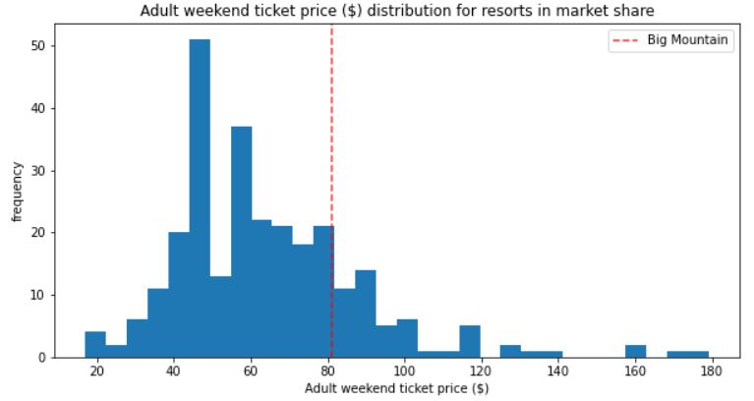

It can be observed that there are still some resorts charging way more than Blue Mountain, at least 45-50 resorts but they are lacking in many departments when compared to Blue Mountain

* In terms of **vertical drop**

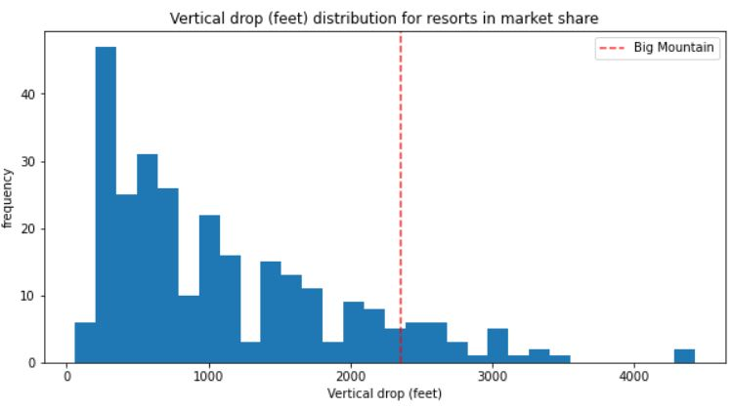

Blue Mountain is pretty good in Vertical drop but still some resorts are ahead of it**, Increasing it can be one of the key factors for increasing the price as shown by my scenario if its increased by 150-200**

* In terms of snow making and number of chairs –

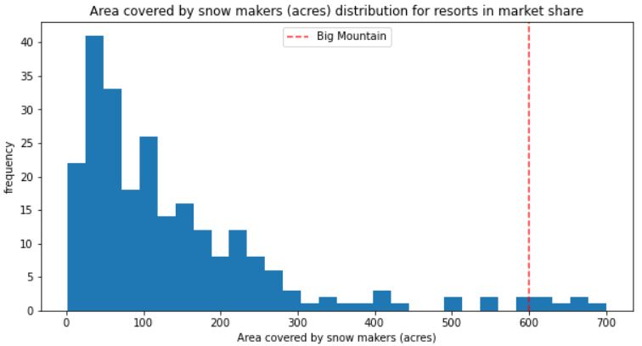 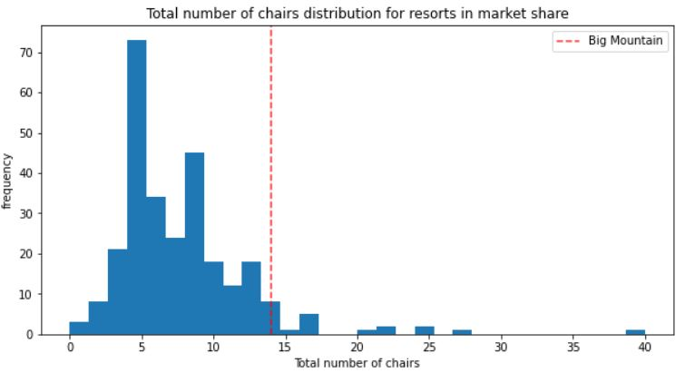

It can be seen that Blue Mountain is already on of the best when it comes to snow making. So increasing this might not help that much. Blue Mountain also surpasses lot of resorts in terms of total chair where some appear to be outliers, but as shown in my scenario if it adds another chair lift, it can increase price by $8, but one also has to take in into consideration the operational cost

* In terms of fast quads & total runs

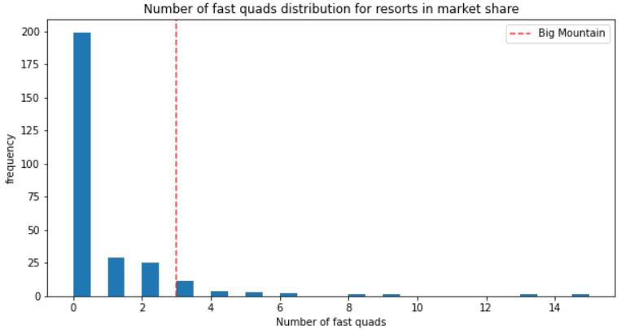 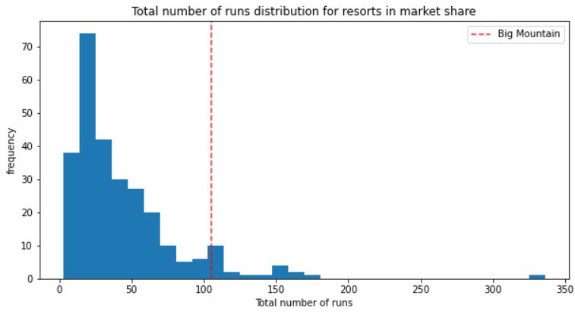

Blue Mountain is also pretty good in terms of fast quads with 3 of them and very few resorts have more. It also compares well in terms of total runs. Increasing them has not much effect on our price

* In terms of longest run and skiable terrain

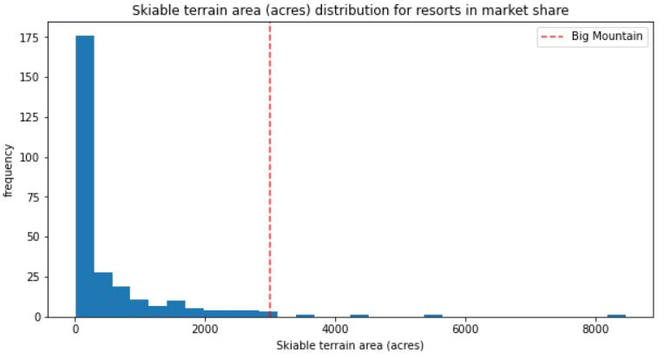 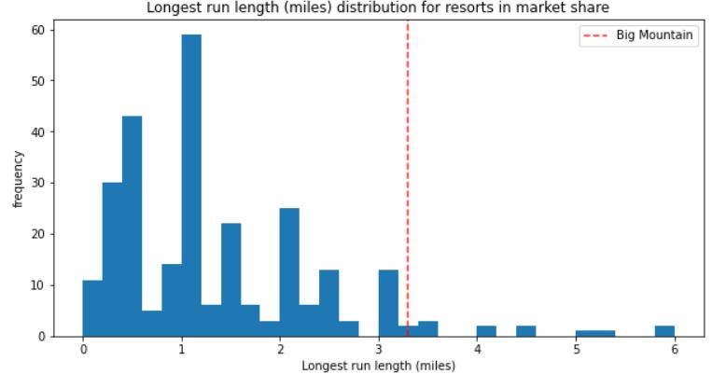

Blue mountain is one of the best in both the departments, it has one of the largest terrains for skiing and long enough longest run compared to other resorts

So at last some scenarios were checked with modifications in the features. It shows that best effective measures that Blue Mountain **can take to increase its price further are: Increase in Vertical Drop, adding chair lift and another run.**